**SUBSIDIARIES’ PROFILE WITH LOGOS**

**CHRIS BAMIDELE ONALAJA FOUNDATION (CBOF)**

Chris Bamidele Onalaja Foundation popularly known as CBOF was created with the vision to contribute to the sustainability, growth and development of humanity. The Foundation’s core areas are;

* Education
* Child and Maternal Health
* Education and Scholarship
* Economic and Community Development
* Widows Empowerment
* Water sanitation and hygiene
* Disease

Over the years, Chris Bamidele Onalaja Foundation has empowered several widows with financial support and skills acquisition trainings; the foundation has also provided support for childcare and youth empowerment

Its community outreach was particularly aggressive during the 2020 COVID-19 lockdown when the foundation through RevolutionPlus Property distributed palliatives to over 1,000 households in Lagos.

The foundation also built a standard private school, TolDel Nursery and Primary school in Ikorodu to provide free education to less privileged children whose parents cannot afford a private school in the axis. Scholarships are also provided for students up to the university level.

Chris Bamidele Onalaja Foundation popularly called CBOF was created by the Group Managing Director of ReveolutionPlus Group, Mr Bmidele Onalaja and his wife who is the Group Executive Director ReveolutionPlus Group, Mrs. Tolulope Onalaja.

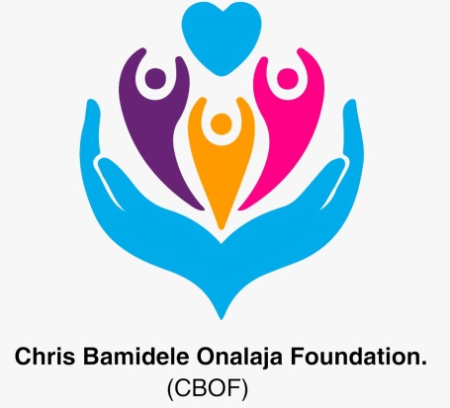

**ANGELIC LINGERIE**

Angelic Lingerie is the trademarked arm of the RevolutionPlus Group birthed from the desire to provide quality and affordable undergarment. The brand stands on the mandate to design comfortable, classy and stylish underwear for both male and female genders. The brand caters for all classes of consumers be it high end or just classy seekers.

Angelic Lingerie has its own registered trademark with customized designs and production line from the United State of America. The brand also sells other high end designers lingerie and labels for customers who have specific preferences.

Angelic Lingerie is situated on the Island with plans to expand outlets across Nigeria.



**REMARKABLE IMPACTS INVESTMENT CLUB**

Remarkable Impacts Investment Club is a subsidiary of RevolutionPlus Group, the most reliable Real Estate Company in Nigeria and Sub-Sahara Africa. The company is driven by the vision to enrich members through investments in Real Estate.

Remarkable Impact Investment Club will provide up-to-date information on Real Estate Investments and grant access to portfolio funds’ investments. Invested funds will be channeled to the development of houses and estates while profit from all investments will be shared amongst members. Members can also use invested funds to purchase some of RevolutionPlus Property’s sites and serviced plots or houses.

Investment capital starts from N 1Million upwards while yearly interest is paid on principal sum invested; return ranges from 5 to 20%.



**REMARKABLE HOTELS & APARTMENTS**

Remarkable Hotels & Apartments Ltd sees to the buying, renovating, developing, building and management of hotels and short let apartments in Nigeria. It offers low-cost short & long term temporary accommodation in various strategic locations on the Island, Mainland and its environs.

With several short let apartments across Lekki axis in Lagos, it is set to extend its reach to the mainland particularly in Ikeja and its surrounding.

Remarkable Hotels & Apartments provides stylish, furnished apartments and homes in great neighborhood at reasonable prices. The Apartments are either 1 or 2 bedroom fully equipped with kitchen, utilities, cookware, dishes, HDTV, free Wi-Fi, inverter, washing machine, parking lots and lots more. They are available for daily or monthly reservations with option of online booking.



**REVOLUTIONPLUS CONSTRUCTION & INFRASTRUCTURE**

RevolutionPlus Construction & Infrastructure is responsible for the constructions and building of houses and Estates. The company is led by professional and experienced engineers who see to the complete construction of your desired plan from the architectural designs down to the actual construction of your building.

Revolutionplus Construction & Infrastructure handles all RevolutionPlus Property and Development Company projects.



**REMARKABLE FOODS LIMITED**

With the global vision to positively impact humanity at every stage of their lives, Remarkable Foods Limited, a subsidiary of the RevolutionPlus Group is created to cater for the everyday consumption needs of Nigerians.

Remarkable Foods boast of classy set up walk in eateries across the Island, world class standard bakery for the productions of different varieties of bread & pastries and a bottled water production line.



**REVOLUTIONPLUS PROPERTY**

RevolutionPlus Property is a foremost real estate company in Nigeria; charged with a vision to be the number one real estate company in Sub-Saharan Africa as well as the world. The company which started operations in 2014 has evolved to have 6 branches in Nigeria and counting with an international office in Dallas, Texas, USA.

The company is driven by its mission to bring buyer’s real estate dreams, desires and expectations to reality through its total commitment to affordable housing using multi-channeled services.

RevolutionPlus Property boasts of owning over 30 estates in Nigeria and several homes for lease in the United States of America. The services of the company include the sales of sites and serviced plots with various affordable houses for sale across Nigeria, property development and real estate advisory. Integrity, trust and timely delivery are the core values of the organization.

RevolutionPlus Property has since evolved into a holding company called Revolution Plus Group which presently has seven (7) subsidiary companies in its portfolio. These companies consist of RevolutionPlus Property Development Company Limited, RevolutionPlus Constructions and Infrastructure Limited, Remarkable Hotels and Apartments Limited, Remarkable Impact Investment Limited, Remarkable Foods Limited, Chris Bamidele Onalaja Foundation and Angelic Lingerie.

RevolutionPlus Property is led by the Managing Director, Mr. Bamidele Onalaja and the Executive Director, Onalaja Tolulope Onalaja with support from qualified Management team.

RevolutionPlus Property is a member of the Real Estate Developers Association of Nigeria (REDAN).

